|  |  |
| --- | --- |
| **S. No.** | **Lab Experiment on Arduino Uno using Autodesk TinkerCad Simulation.** |
| **1** | **a)Write the code to blink an LED on Arduino Uno. Compile and verify the result on the serial monitor of Arduino IDE.**  **Additional Programs:**   1. **To blink two LED’s alternatively** 2. **To blink odd and even leds** 3. **To scroll an LED’s** |
| **2** | **Interfacing of Arduino Uno with LED and switch. Write a program to**  **control LED using Switch.**  **Additional Programs:**  **i)Single switch to control multiple LED’s**  **ii)Multi switches to control multiple LED’s** |
| **3** | **Interfacing of Arduino Uno with potentiometer and LED. Write a program to vary the intensity of LED using a potentiometer.**  **Additional Programs:**  **i)Adjust the brightness of LED without potentiometer.** |
| **4** | 1. **Interfacing of Ultrasonic sensor with Arduino Uno. Write a program to measure the distance from obstacle and display on the serial monitor.** 2. **Interface an IR sensor with Arduino Uno. Write a program to detect obstacle and display on the serial monitor.** |
| **5** | 1. **Interfacing of Temperature sensor with Arduino Uno. Write a program to read the specific temperature of a room and display on the serial monitor.** 2. **Interfacing of LDR with Arduino Uno. Write a program to control the intensity of LED using LDR.** |
| **6** | 1. **Interfacing of DC motor with Arduino Uno. Write a program to rotate the motor in clockwise and anticlockwise direction with using a delay of 2 sec.** 2. **Familiarize the concept of pulse width modulation. Write a program to control the speed of DC motor using PWM.** |
| **7** | 1. **Interfacing of a display device, i.e., LCD x2 with Arduino Uno. Write a**   **program to display “HELLO IOT” on LCD.**   1. **Write a program to scroll the message “Welcome to IoT Lab.”** 2. **Write a program to blink the message “Hello IoT.”** |

# EXPERIMENT 1

**Aim of the Experiment:** To Blink LED

**Components Used:** Arduino UNO, LED, Resistor**,** Tinkercad Simulator.

## Circuit Diagram:

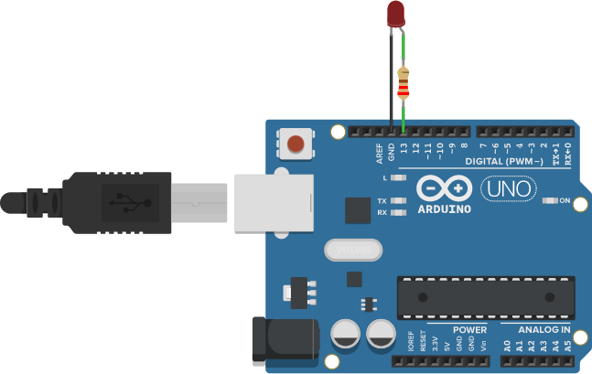

**Figure : Blinking of LED**

## Software program:

void setup()

{

pinMode(13, OUTPUT); Serial.begin(9600);

}

void loop()

{

digitalWrite(13, HIGH); Serial.println("LED : ON");

delay(1000); // Wait for 1000 millisecond(s) digitalWrite(13, LOW); Serial.println("LED : OFF");

delay(1000); // Wait for 1000 millisecond(s)

}

## Screenshot of Serial monitor:

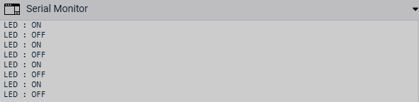

# EXPERIMENT 2

**Aim of the Experiment:** Controlling LED with Switch.

**Components Used:** Arduino UNO, LED, Resistor**,** Tinkercad Simulator, Switch.

## Circuit Diagram:

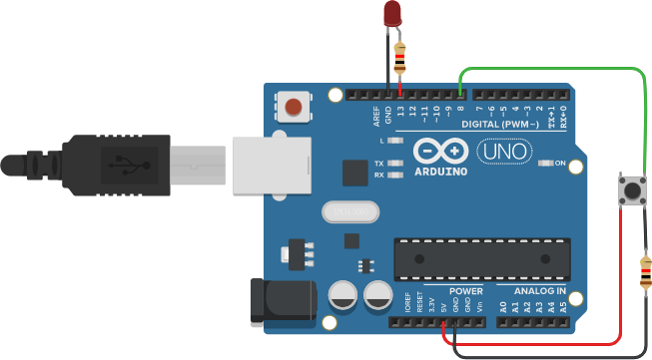

**Figure : Control of LED using Switch**

## Software program:

void setup()

{

pinMode(13, OUTPUT); Serial.begin(9600);

}

void loop()

{

digitalWrite(13, HIGH); Serial.println("LED : ON");

delay(1000); // Wait for 1000 millisecond(s) digitalWrite(13, LOW); Serial.println("LED : OFF");

delay(1000); // Wait for 1000 millisecond(s)

}

# EXPERIMENT 3

**Aim of the Experiment** : Intensity of Led using Potentiometer .

**Components Used :** Arduino UNO,Led,Potentiometer,Resistor,Tinckercad simulator .

**Circuit Diagram:**

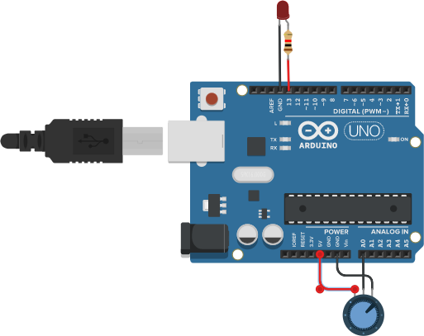

**Figure : Intensity of Led using Potentiometer**

## Software program:

int value=0; void setup()

{

pinMode(A0, INPUT); pinMode(11, OUTPUT);

}

void loop()

{

value = analogRead(A0); digitalWrite(11,HIGH); delay(value);

digitalWrite(11, LOW); delay(value);

}

# EXPERIMENT 4(a)

### **Aim of the Experiment:** Measure the distance from obstacle and display on the serial monitor using ultrasonic sensor

**Components Used:** Arduino UNO, Ultrasonic sensor, Tinkercad Simulator.

**Circuit Diagram:**

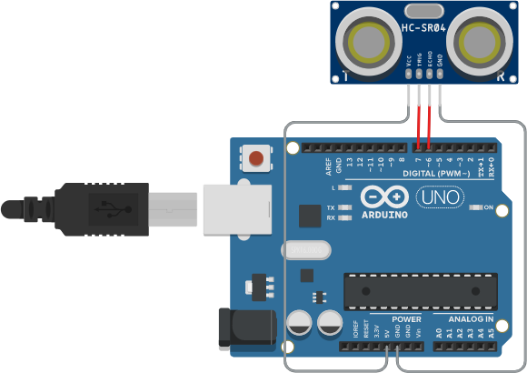

**Figure : Ultrasonic Sensor**

## Software program:

const int trigpin =6; const int echopin =7; int distance;

int duration; void setup()

{

pinMode(trigpin, OUTPUT); pinMode(echopin, INPUT); Serial.begin(9600);

}

void loop()

{

digitalWrite(trigpin, LOW); delayMicroseconds(2); digitalWrite(trigpin, HIGH); delayMicroseconds(10); digitalWrite(trigpin, LOW); duration = pulseIn(echopin, HIGH); distance = (0.034*duration)/2; Serial.print("Distance is ="); Serial.println(distance);

}

## Screenshot of Serial monitor:

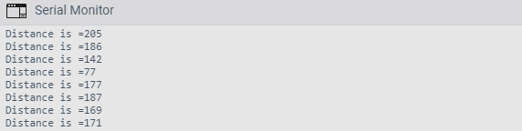

**EXPERIMENT 4(b)**

**Aim of the Experiment:** To Detect Obstacle.

**Components Used:** Arduino UNO, IR Sensor, IR Remote, Tinkercad Simulator.

## Circuit Diagram :

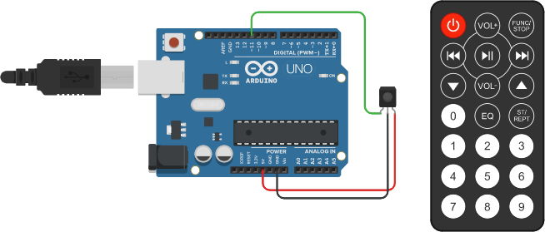

**Figure : Setup of IR Sensor**

## Software program:

int ir;

void setup()

{

pinMode(11,INPUT);

Serial.begin(9600);

}

void loop()

{

ir=digitalRead(11); Serial.println(ir);

}

## Screenshot of Serial monitor:

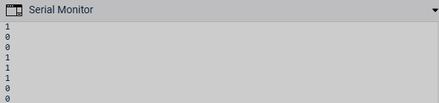

**EXPERIMENT 5(a)**

**Aim of the Experiment:** To read the specific temperature of a room.

### **Components Used:** Arduino UNO, Temprature Sensor, Resistor, LCD, Potentiometre, Tinkercad Simulator.

**Circuit Diagram:**

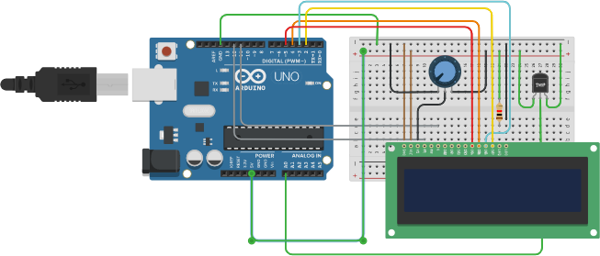

**Figure : Temprature Sensor**

## Software program:

#include <LiquidCrystal.h>

int sensePin = A0; int sensorInput; double temp;

LiquidCrystal lcd(12,11,5,4,3,2);

void setup()

{

Serial.begin(9600); lcd.begin(16,2);

}

void loop()

{

sensorInput = analogRead(A0); temp = (double)sensorInput / 1024; temp = temp * 5;

temp = temp - 0.5; temp = temp * 100; lcd.setCursor(0,0); lcd.print("Temp:"); lcd.setCursor(6,0); lcd.print(temp);

Serial.print("Current Temperature: "); Serial.println(temp);

}

## Screenshot of Serial monitor:

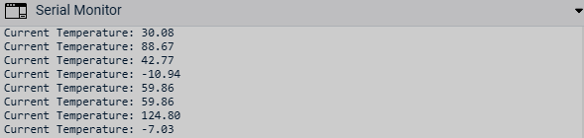

**EXPERIMENT 5(b)**

**Aim of the Experiment:** Controlling the intensity of LED using LDR.

**Components Used:** Arduino UNO, LED, Photoresistor, Resistor,Tinkercad Simulation.

## Circuit Diagram:

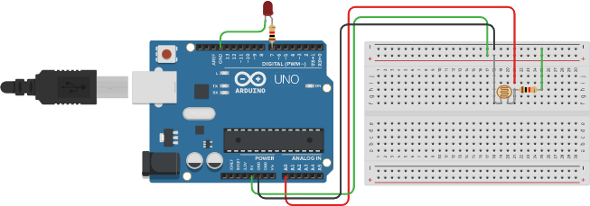

**Figure Controlling intensity of LED using LDR**

## Software program:

const int ledPin = 7; const int ldrPin = A0; void setup()

{

Serial.begin(9600); pinMode(ledPin, OUTPUT); pinMode(ldrPin, INPUT);

}

void loop()

{

int ldrStatus = analogRead(ldrPin); if (ldrStatus <= 200)

{

digitalWrite(ledPin, HIGH);

Serial.print("Its DARK, Turn on the LED : "); Serial.println(ldrStatus);

}

else

{

digitalWrite(ledPin, LOW);

Serial.print("Its BRIGHT, Turn off the LED : "); Serial.println(ldrStatus);

}

}

## Screenshot of Serial monitor:

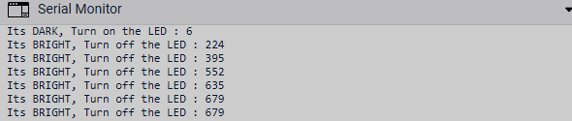

**EXPERIMENT 6(a)**

**Aim of the Experiment:** Rotating a DC Motor in clockwise & anticlockwise direction using delay.

### **Components Used:** Arduino UNO, DC Motor, H- Bridge Motor Driver, Tinkercad Stimulation.

**Circuit Diagram:**

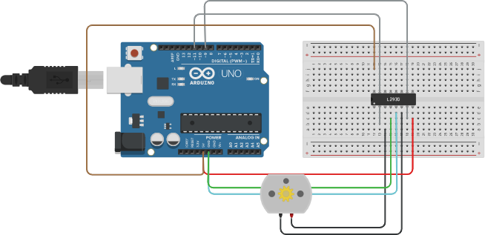

**Figure Rotating DC motor**

## Software program:

int In1=12; int In2=9; void setup()

{

pinMode(In1,OUTPUT); pinMode(In2,OUTPUT); Serial.begin(9600);

}

void loop()

{

digitalWrite(In1,HIGH); digitalWrite(In2,LOW); Serial.println(“Clockwise”); delay(2000); digitalWrite(In1,LOW); digitalWrite(In2,HIGH); Serial.println(“Anti Clockwise”); delay(2000); digitalWrite(In1,LOW); digitalWrite(In2,LOW); Serial.println(“Stop”); delay(2000);

}

## Screenshot of Serial Monitor:

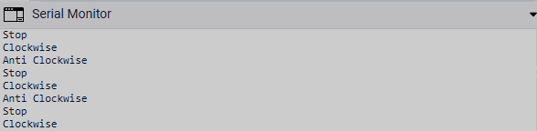

**EXPERIMENT 6(b)**

**Aim of the Experiment:** Control the speed of DC motor using PWM. **Components Used:** Arduino UNO, DC Motor, Tinkercad Simulator. **Circuit Diagram:**

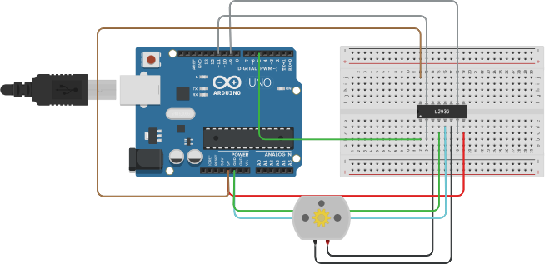

**Figure : Rotating DC Motor**

## Software program:

int en=5;

int In1=12; int In2=9; void setup()

{

pinMode(en,OUTPUT); pinMode(In1,OUTPUT); pinMode(In2,OUTPUT); Serial.begin(9600);

}

void loop()

{

analogWrite(en,255); digitalWrite(In1,HIGH); digitalWrite(In2,LOW); Serial.println("Clockwise"); delay(2000); analogWrite(en,255); digitalWrite(In1,LOW); digitalWrite(In2,HIGH); Serial.println("Anti Clockwise"); delay(2000); analogWrite(en,255); digitalWrite(In1,LOW); digitalWrite(In2,LOW); Serial.println("Stop"); delay(2000);

}

## Screenshot of Serial monitor:



**EXPERIMENT 7(a)**

**Aim of the Experiment:** Display “HELLO IOT” on LCD.

**Components Used:** Arduino UNO, LCD, Potentiometer, Resistor,Tinkercad Simulator.

## Circuit Diagram:

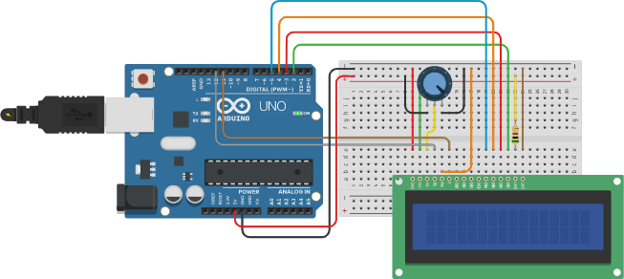

**Figure : Setup for Print of Hello Iot**

## Software program:

#include <LiquidCrystal.h> LiquidCrystal lcd(12,11,5,4,3,2); void setup()

{

lcd.begin(16, 2);

}

void loop()

{

lcd.setCursor(4,0); lcd.print("Hello IoT"); delay(1000);

}

# EXPERIMENT 7(b)

**Aim of the Experiment:** Scroll the message “Welcome to IoT Lab”.

**Components Used:** Arduino UNO, Tinkercad Simulation, LCD, Potentiometer, Resistor.

## Circuit Diagram:



**Figure Setup for Scrolling.**

## Software program:

#include <LiquidCrystal.h>

const int rs = 12, en = 11, d4 = 5, d5 = 4, d6 = 3, d7 = 2; LiquidCrystal lcd(rs, en, d4, d5, d6, d7);

void setup()

{ lcd.begin(16, 2);

lcd.print("hello, world!"); delay(1000); }

void loop()

{ for (int positionCounter = 0; positionCounter < 13; positionCounter++)

{ lcd.scrollDisplayLeft(); delay(150); }

for (int positionCounter = 0; positionCounter < 16; positionCounter++)

{ lcd.scrollDisplayLeft(); delay(150); }

}

### 3

**EXPERIMENT 7(c)**

**Aim of the Experiment:** Blinking the message “Hello IoT”.

**Components Used:** Arduino UNO, Tinkercad Simulation, LCD, Resistor, Potentiometer.

## Circuit Diagram:



**Figure Setup for Blinking**

## Software program:

#include <LiquidCrystal.h> LiquidCrystal lcd(12,11,5,4,3,2); void setup()

{ lcd.begin(16, 2); } void loop()

{

lcd.setCursor(4,0); lcd.print("Hello IoT"); delay(1000); lcd.clear(); delay(500);

}